Laboratory 6: Installation of Internet Information Services and Configuration of the Default Website
Version 260408

Legend – colors and fonts used in the instructions
Green color: notes, additional information, must be read
Blue color: places to write down and include in the report. Often requires a screenshot
Red color: very important information
Monospace font: commands, cod

Number of points: 5
Installation of Internet Information Services
Host: DC1
During this task, Internet Information Services will be installed. The Web Server (IIS) role will be installed.
Note: The following steps and screenshots may differ depending on the Windows Server version.
- Launch Server Manager.
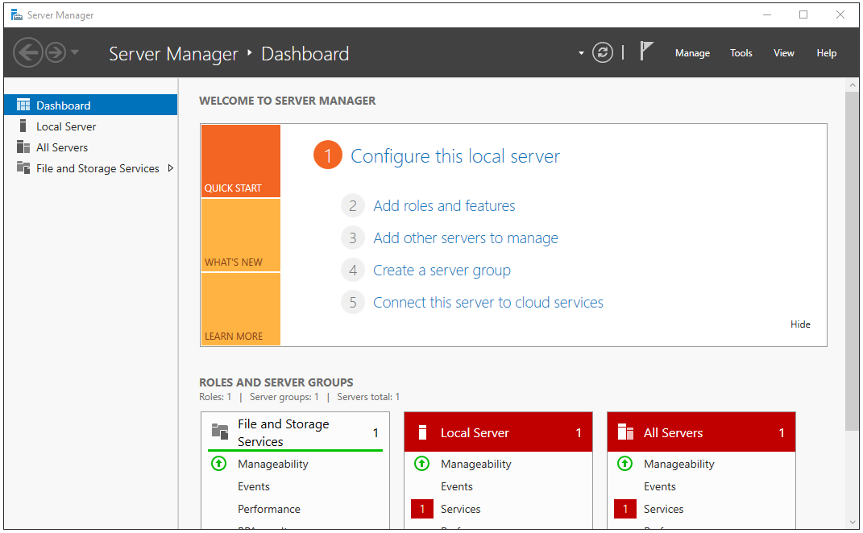
- Add Roles and Features.
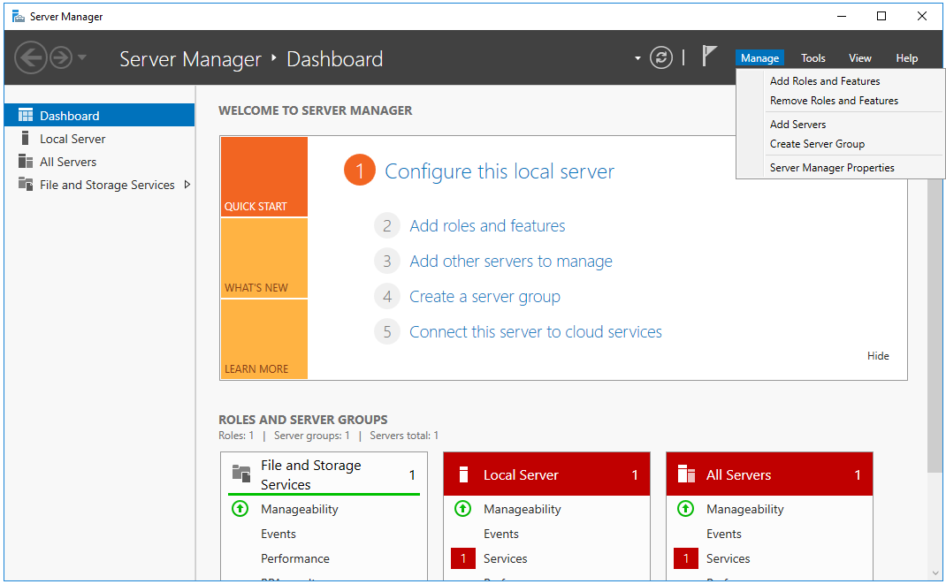

- Select installation type: Role-based or feature-based installation.
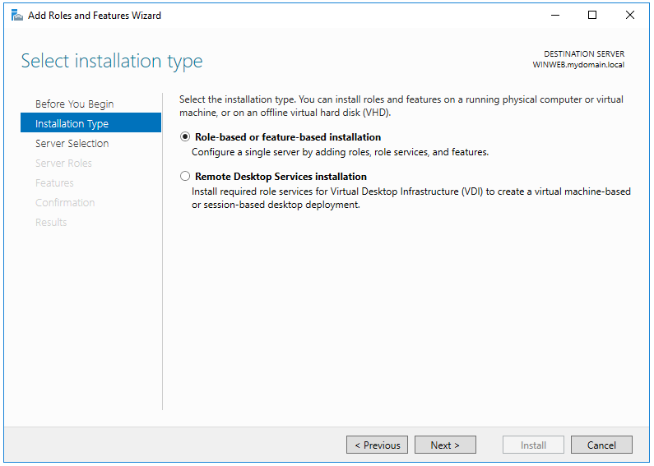
- Select destination server: Select a server from the server pool -DC1.
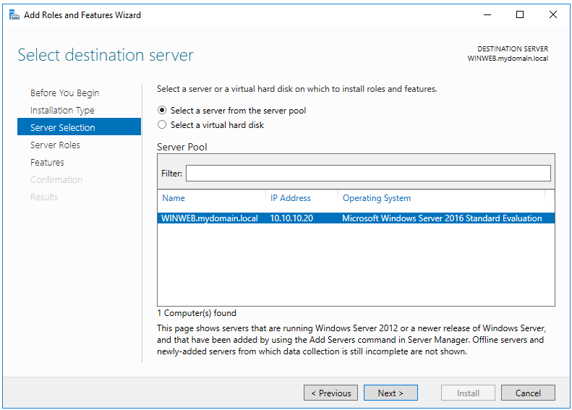

- Select server roles -> Roles ->Web Server (IIS).
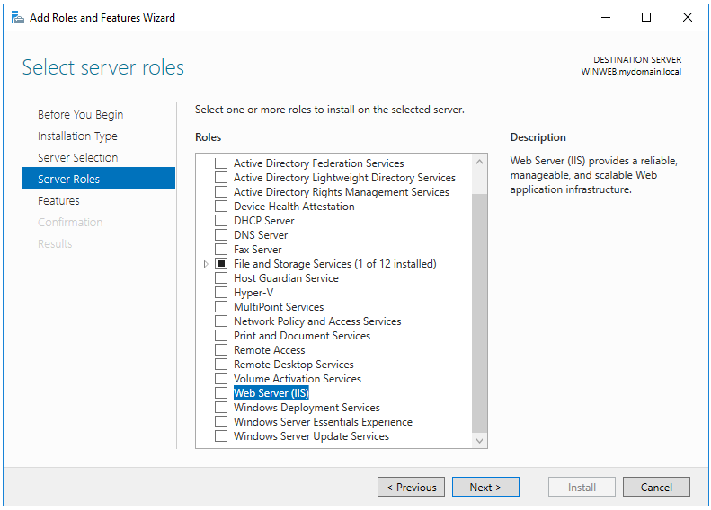
- Select server roles - select next.
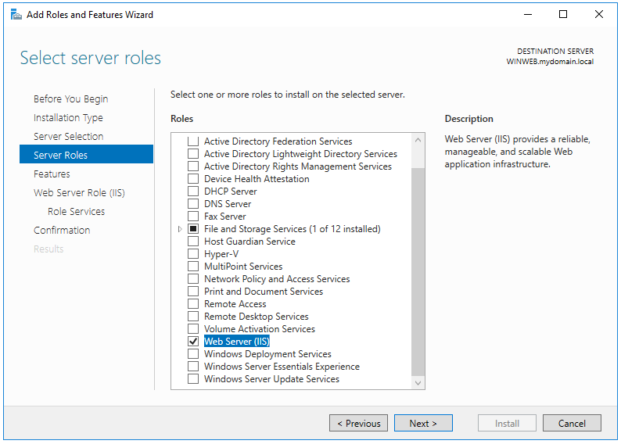

- Select features - next.
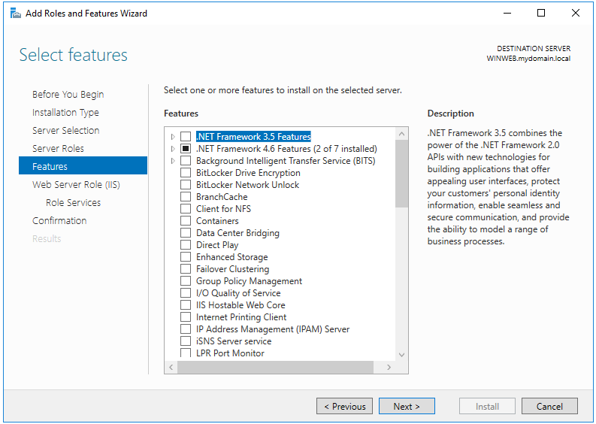
- Web Server Role (IIS) – select next.
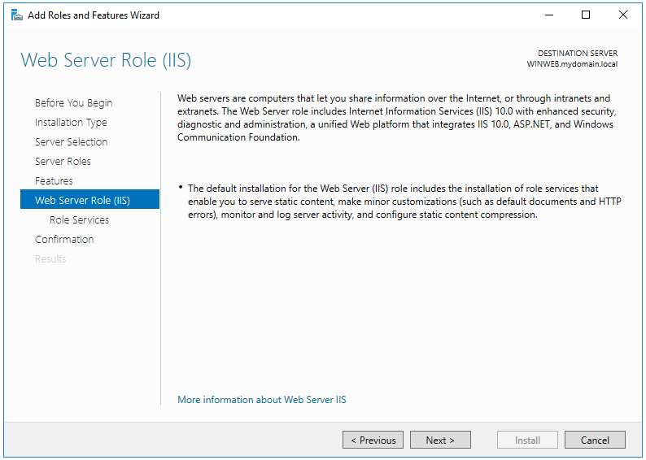

- Select role services page: default roles and next.
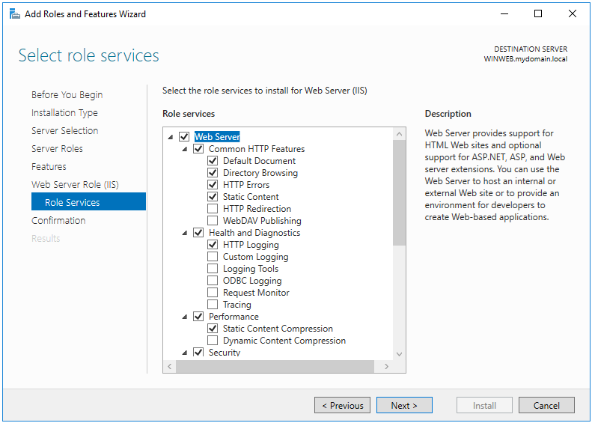
- Confirm installatio - select Install.
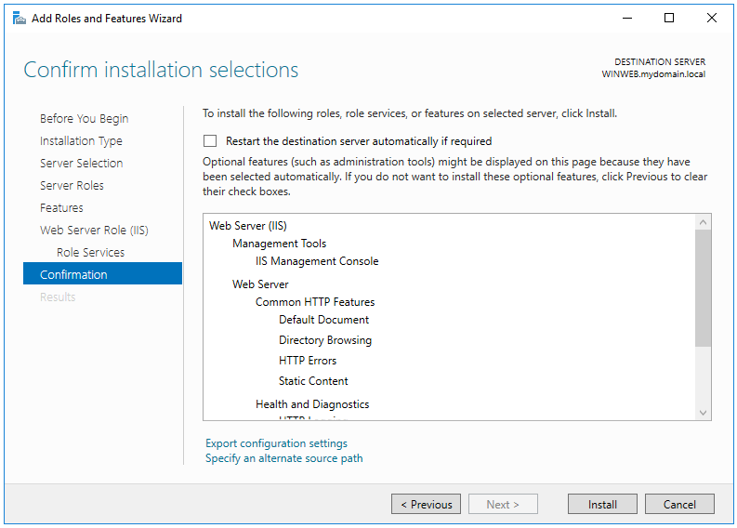

- Installation Progress.
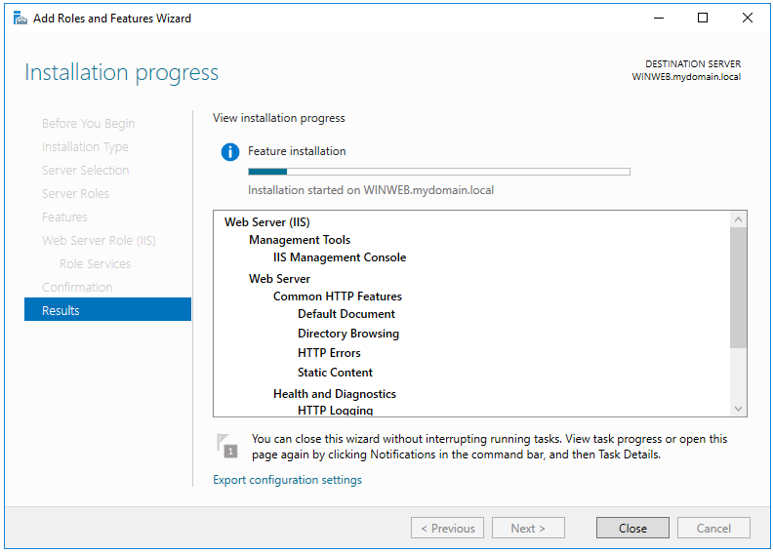
- After successful installation, close the Add Roles and Features Wizard
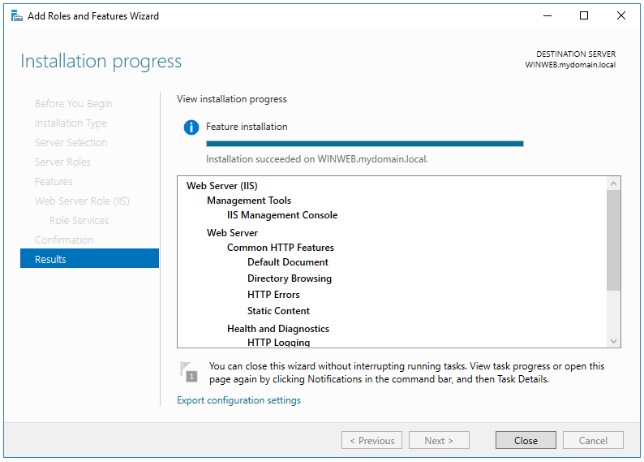
- Launch Windows PowerShell.
- Verify that IIS is installed and running on the computer. Execute the command:
Get-Service W3SVC.
If any errors appear, take appropriate corrective actions.
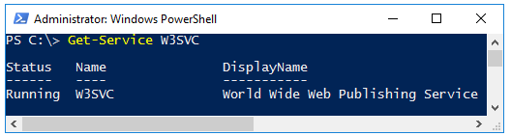

+1 Verify the operation of the web server and open the default page from browser
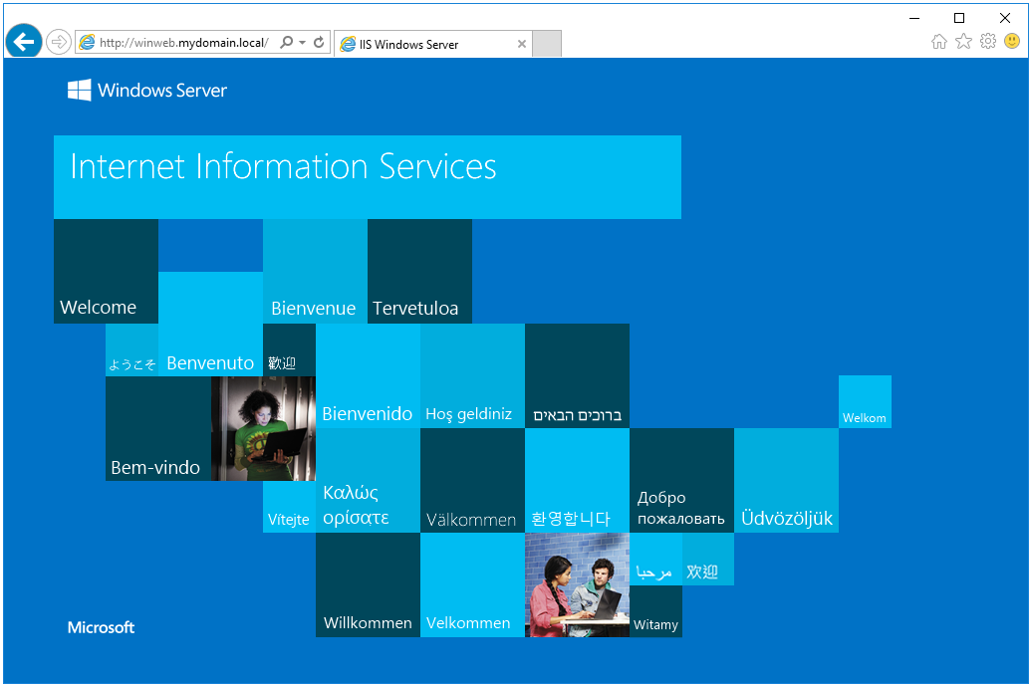
Configuration of the Default Website
Note: In the following steps, if the DNS server is not working, use the appropriate IP address.
Host: DC1
During this task, a new homepage, subpages, and a virtual directory will be added to the default IIS website.
- In the default folder C:\inetpub\wwwroot create a new file default.htm.
- Open any text editor and add the following code:

<!DOCTYPE html>
<html>
<head>
<meta charset="UTF-8">
<title> Default Web Site </title>
</head>
<body>
<h3>Host: DC1</h3>
<p> Strona Default Web Site - plik <i>default.htm</i></p>
</body>
</html>
Try to personalize this page.
- Open a web browser and verify that the created page default.htm is displayed as default:.
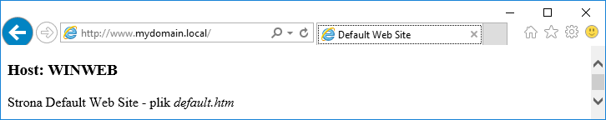
- In the folder C:\inetpub\wwwroot create a new file index.htm.

<!DOCTYPE html>
<html>
<head>
<meta charset="UTF-8">
<title> Default Web Site </title>
</head>
<body>
<h3>Host: DC1</h3>
<p> Strona Default Web Site - plik <i>index.htm</i></p>
</body>
</html>
Try to personalize this page.
- Open the browser and check whether index.htm is displayed as default. The page default.htm should still be displayed

- Rename default.htm to default.htm.bak.
- Open the browser again and verify that index.htm is now displayed as default.
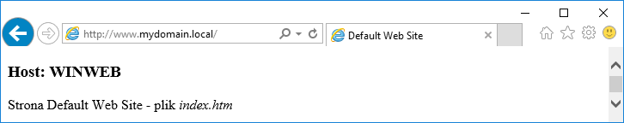
- Create subfolder in C:\inetpub\wwwroot: subdef.
- Inside subdef create: default.htm.

<!DOCTYPE html>
<html>
<head>
<meta charset="UTF-8">
<title> Default Web Site </title>
</head>
<body>
<h3>Host: DC1</h3>
<p> Strona Default Web Site - plik <i>subdef/page.htm</i></p>
</body>
</html>
Try to personalize this page.
- Verify that the page is displayed.
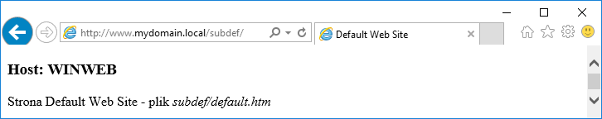
- In C:\inetpub\wwwroot create folder subpage.
- Inside create file page.htm.

<!DOCTYPE html>
<html>
<head>
<meta charset="UTF-8">
<title> Default Web Site </title>
</head>
<body>
<h3>Host: DC1</h3>
<p> Strona Default Web Site - plik <i>subpage/page.htm</i></p>
</body>
</html>
Try to personalize this page.
- Try to open the page using URL address server IP/subpage in browser. Now the page should be displayed.
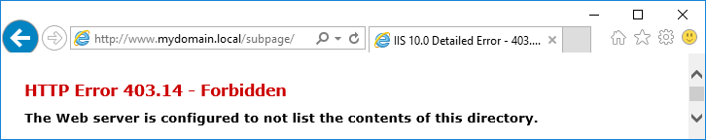
- Add the page name to the URL path http://SERVER/subpage/page.htm. The page should be displayed correctly.
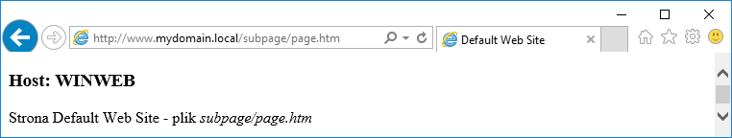
+2 Write down the order in which pages are opened.

- Create folder: C:\www\documents.
- Inside C:\www\documents Create: default.htm.

<!DOCTYPE html>
<html>
<head>
<meta charset="UTF-8">
<title> Default Web Site </title>
</head>
<body>
<h3>Host: DC1</h3>
<p> Strona z folderu wirtualnego - plik <i>default.htm</i></p>
</body>
</html>
Try to personalize this page.
- Open IIS Manager.
- Select: Connections → DC1 → Sites → Default Web Site
- Right click -> Add Virtual Directory.
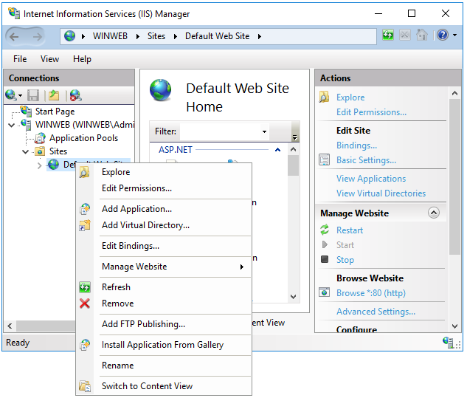
- Add Virtual Directory -> Alias: docs, Physical Path: C:\www\documents.

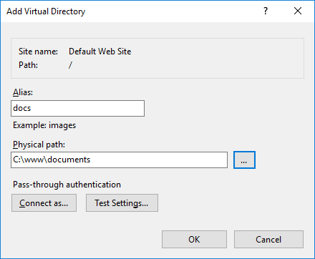
- Open http://SERVER/docs. The page should be displayed
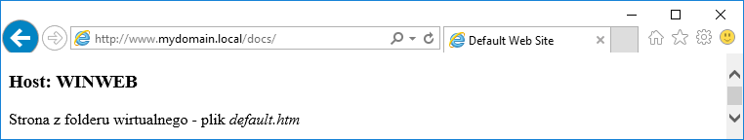
+3 take a screenshot
- Open http://NEIGHBOR_SERVER/[different URLS]. The page should be displayed
Use the neighbor IP address form bridged NIC.
Take a screenshot
Configuration of Website Bindings (IP, Ports, Hosts)
Host: DC1
During this task, basic settings of the default website will be configured.
- Use the second NIC address (NAT)
- Start Internet Information Services (IIS) Manager.
- Connections → DC1 → Sites → Default Web Site.
- Actions → Bindings.

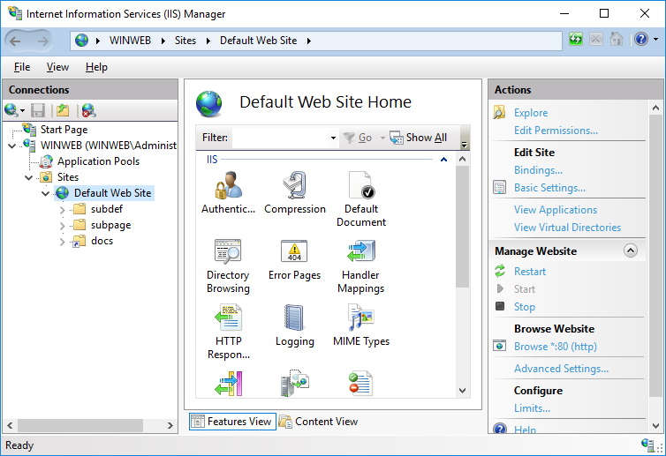
- Site Bindings ->http -> Edit.
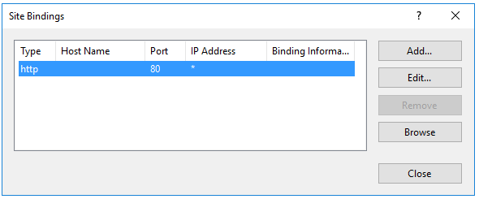
- IP address, sue the second NIC (NAT) IP address.
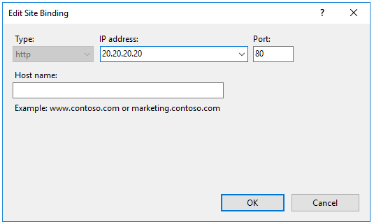
- Close Site Bindings.
- Connections -> Sites.
- Window Feauture view -> Default Website -> column Binding should contains: NIC NAT address:80 (http).
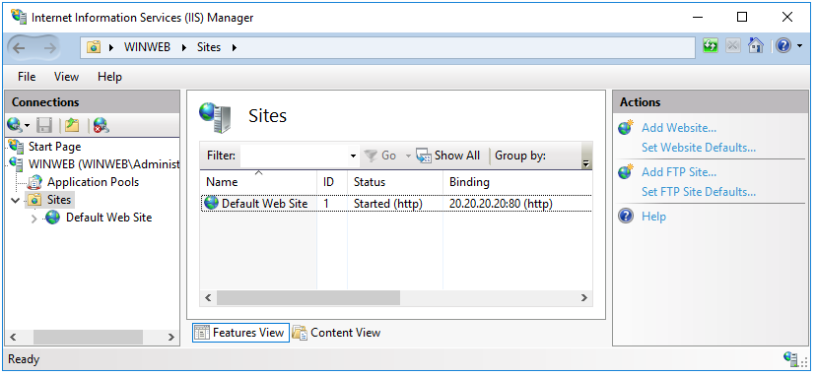
- Close Internet Information Services (IIS) Manager.
- Open web browser and use the URL with the LAN srever address. Page should NOT be displayed.
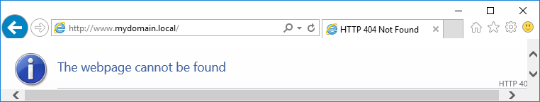
- Open web browser and use the URL with the NAT NIC address. Page should be displayed.
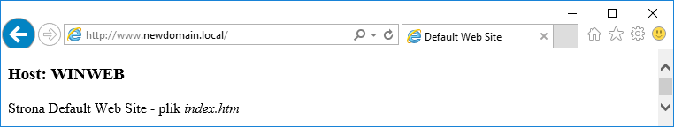
+4 Take a screenshot
- Start Internet Information Services (IIS) Manager.
- Connections ->DC1 -> Sites -> Default Web Site.
- In Action panel change Bindings.
- Site Bindings -> http -> Edit.
- IP address _> All Unassigned, Port -> 8282.
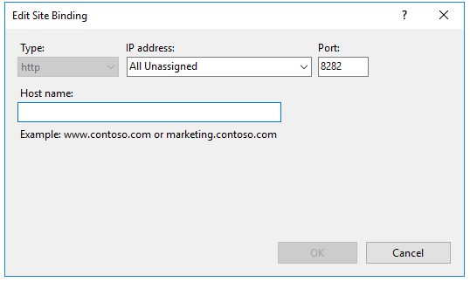
- Cose Edit Site Bindings.Click OK.
- Connections -> Sites -> Default Website -> Bindings shuld be configured with *:8282 (http).
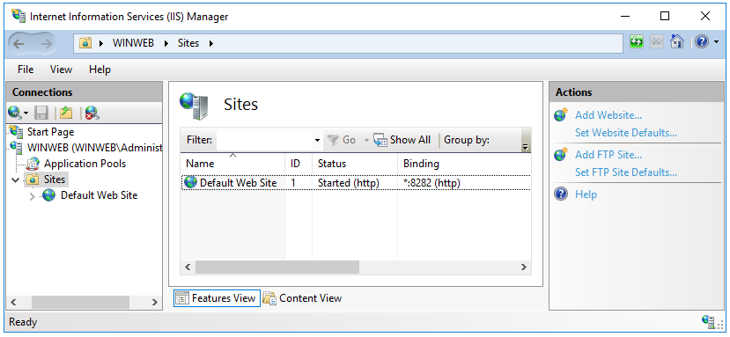
- Close Internet Information Services (IIS) Manager.
- From the client VM CL1 try to open the server page at port 8282: http://SERVER_IP:8282.
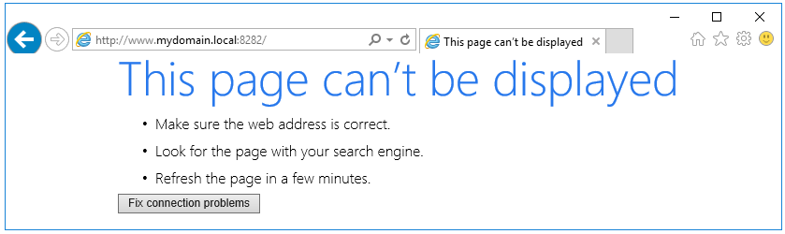
- Check and configure DC1 firewall settings. On DC1 start Windows Firewall.
- Windows Firewall -> Advanced settings -> Advanced Security -> Inbound Rules -> New Rule (right mouse click).
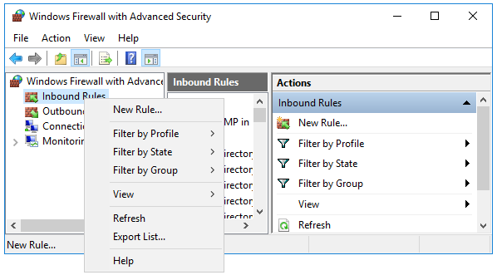
- New Inbound Rule Wizard ->Port.
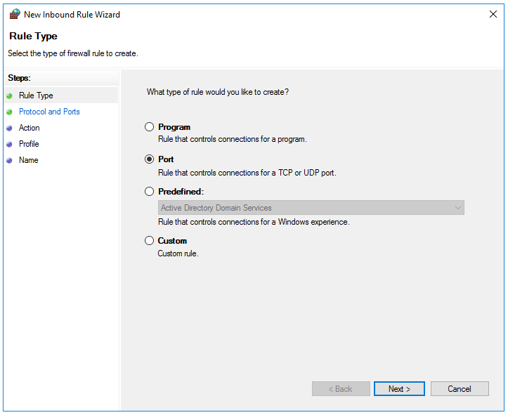

- Protocol and Ports select TCP and set Specific local ports to 8282.
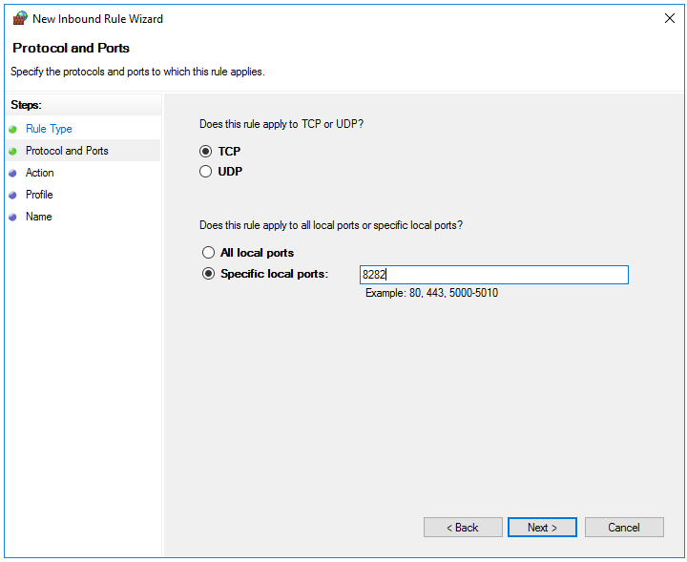
- Action -> Allow the connection.
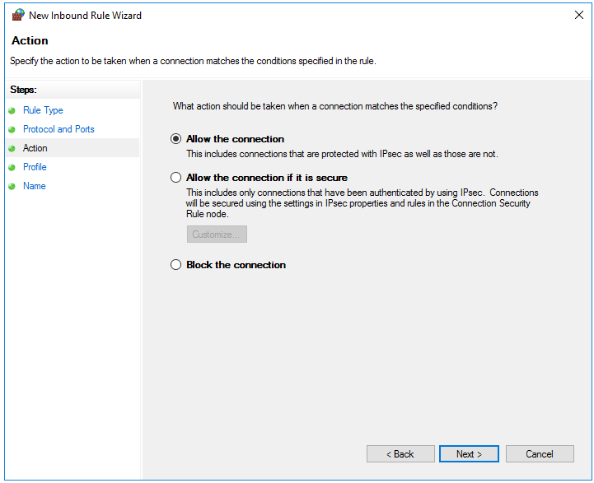

- Profile – select all.
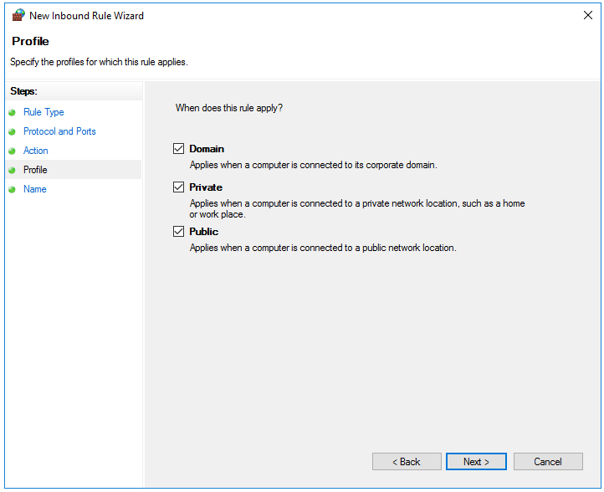
- Name -> Name: write HTTP Traffic-in (Port 8282), and click Finish.
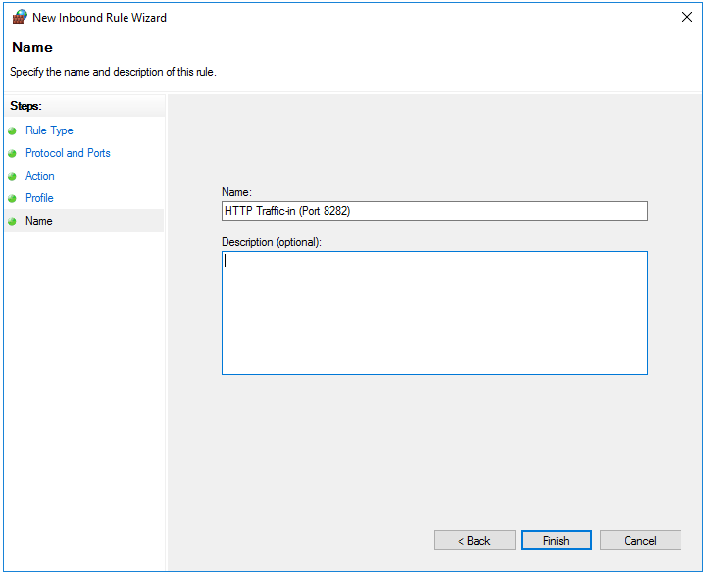
- The roule should appear in Inbound Rules pannel.
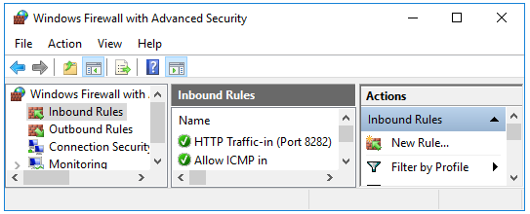
- Close Windows Firewall.
- Open Web Browser on CL1 and open the page again. Page should be displayed.
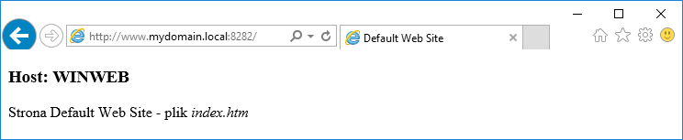
+5 Take a screenshot of the page opened with port 8282

